Shebbear Community School – Recovery Plan September 2020
Shebbear Community School is determined that all pupils are given the opportunity to be ‘back on track’ as quickly as possible when all pupils return full time in September. We will focus on ensuring routines, expectations, standards, relationships and values are quickly re-established. We will be making both academic and emotional well-being our absolute priority.
The three key strands for September will be:
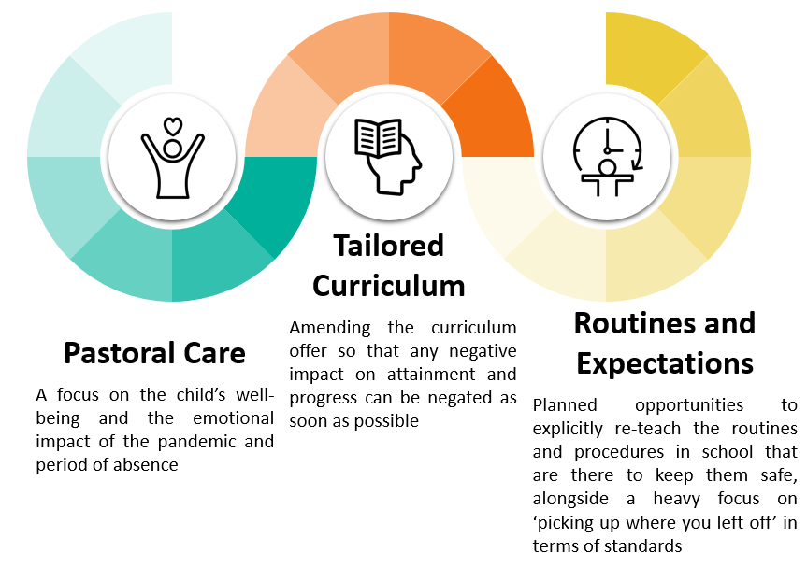
Taking in to account that pupils will return to school with varying experiences over the last few months, the level of support will be implemented in a tiered approach.
Universal Support – The provision that is applicable to all children in school
Focussed Support – Additional measures for groups of children that can be delivered through class provision or additional family contact
Targeted Support – Specific support for individuals or families
Pastoral Care
Universal Support | Focused Support | Targeted Support
- Children who demonstrate changes in behaviour are to be referred to DSL  - Maintain communications through Class Dojo, website, Facebook page and sharing of class work with parents to maintain that ‘connection’  - PSHE to focus on change, anxiety and mindfulness – any cause for concern to be referred to DSL  - Environments to be welcoming and celebration achievements of children as a motivator – welcoming to pupils moving to a new classroom  - Whole school assemblies to still maintain a ‘togetherness’ including celebrating the successes of the week  - Establish up-to-date contact details (especially emails) from parents | - Class teachers to speak to families who have experienced trauma/change in circumstances – what help do they need?  - Opportunities for group or whole-class reading sessions – focussed conversations on vocabulary and emotional literacy using books about perseverance, resilience and mindfulness  - Acknowledge children who may initially struggle to pick up on the pace on the learning  - Where teachers feel it is appropriate, whole-class opportunities for activities to support strong mental health and well-being such as mindfulness | - Bereavement support for those children/families identified  - Referrals to external agencies where concerns have been identified  - Provide/receive an update for CP/CIN/Early Help/Vulnerable families through contact with social worker and other external bodies  - School nursing referrals for children returning with additional/altered medical concerns (not neglecting mental health)

Tailored Curriculum
Universal Support | Focused Support | Targeted Support
- Teaching staff to be mindful that any perceived ‘drops’ in standards are not deliberate, but an upturn in standards requires deliberate practice.  - A focus on handwriting and presentation to quickly re-establish high standards – not necessarily explicit sessions, but a heavily promoted class culture  - Phonics to be delivered regularly and with rigour, revising sounds that children may have forgotten.  - Regular reading lessons that foster the love of reading and book enjoyment, but that focus on discussion and promote speaking and listening.  - Writing is to be regular and across the curriculum. Lots of short-burst writing to promote writing stamina, but also revision of sentence structures. Dedicated time to write daily and creatively using, as appropriate, resources such as www.pobble365.com.  - Maths is to focus on number work with a daily arithmetic session. TT Rock Stars etc to be accessed regularly to support automaticity of recall – retrieval practice heavily used also.  - Computing curriculum to focus on online safety and up-skilling pupils in using Google Docs  - PE curriculum to focus on fitness – children are to actively increase their activity levels, beyond ‘games’  - ‘End of year’ assessments in October | - SENDCO to contact families to discuss provision this year and share provision mapping so they know what support their child will be receiving.  - Child voice is to be acknowledged and care to not disengage reluctant pupils  - Promote independent learning for those that have become particularly reliant on an adult (through home-learning).  - Ensure that appropriate groups receive curricular support but that scaffolding is withdrawn quickly so that emphasis is placed on children being independent learners.  - Gaps in non-core curriculum to be identified where possible and re-caps through lesson starters and quizzes used (in particular core knowledge in science, history, geography and RE)  - Teachers are to identify online resources that may support this such as BBC Bitesize, Oak National Academy  - Ongoing assessments to build up a clear picture of gaps in knowledge so appropriate support can be put in place | - Children who have not engaged in any home-learning to receive specific focus/intervention to support them in quickly returning back to pre-COVID level.  - Learning support & Ed Psych support to identify and focus on specific children.  - Appropriate adults to work safely with children, by way of intervention –agreement with the class teacher about the child’s priority learning.
Routines and Expectations
Universal Support | Focused Support | Targeted Support
- Strong emphasis from day one on ‘Every lesson, every day’ ‘over-communicate’ these principles at all opportunities  - Continued focus on expectations of behaviour, standards of work, work ethic  - Daily reminders on hand washing routines and importance of safety around the school (maintaining the bubbles)  - All staff to be responsible for the behaviour and attitudes of all children, whilst also acknowledging an adjustment period. | - Immediate use of house points to foster good learning behaviours and attitudes to one another. Relate these to the school values and new protective measures.  - Regular reminder for those struggling to distance and follow hygiene procedures. Again, this is everyone’s responsibility. If children are not seen adhering, we are all to address it.  - Specific group conversations or assemblies (distanced) as required if there are pockets of children that are not following expectations.  - Quickly identify groups of children that are not attending as regularly as expected. | - Provide additional support materials for those requiring it.  - EWO to conduct home-visits for those children with a particularly poor start in terms of attendance.  - If individuals stand out as being unable to quickly return to the Shebbear expectations, contact with parents is to be made and a behaviour plan drawn up (if related to poor behaviour).  - Specific praise needs to be given to those children that have adapted well (in their own context).  - This praise can be awarded in class, through virtual assemblies or through messages to parents on Class Dojo.  At all stages, we must acknowledge that some children will need more time than others to adjust and ‘return as normal’.  We must also acknowledge, in particular, those pupils who are new to the school including the new reception children who will have missed much of their final term at pre-school.

