Shebbear Community School
Equality Objectives – reviewed and monitored by the full Governing Body 23rd March 2023 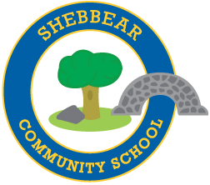
We have three published equality objectives:
 | Equality Objective | How achieved | Evidence of Governor Monitoring
1 | Promote equal opportunity for all | Discussion with minority group of older girls (d)  Accessibility plan (e) | Governing Body minutes and Head Teacher’s report  School website
2 | Promote positive attitudes | School visits e.g. Mosque, Synagogue, Cathedral (b) | Governing Body minutes and Head Teacher’s report
3 | Value and include every member of our community | Diversity Week (c) (f)  Annual school library audit (c)  Statutory reports (a) (d)  Weekly awards in assembly (d) | Governing Body minutes and Head Teacher’s report.  Weekly newsletter to parents  Pupil Premium report, Covid Catch-up plan  SEN annual report to governors  School website.

These are addressed in school by:
a) Ensuring that all strategic and administrative decisions are made only after carefully consideration of equality matters.
b) Promoting cultural understanding, and awareness of different religious beliefs, within and beyond our school community, through the curriculum, visits and events.
c) Promoting the understanding of, and positive attitudes towards disability.
d) Actively closing gaps in attainment and achievement between students and all groups of students; especially students from disadvantaged backgrounds, students with special educational needs and disabilities, looked after children and students from minority ethnic groups.
e) Continue to improve accessibility across the school for students, staff and visitors with disabilities, including the physical environment, curriculum and school policies
f) Ensure that no student, member of staff or visitor is at a disadvantage, or unable to participate fully in the life of the school

